20. Write a program to perform the following operations:

a) Insert an element into a AVL tree

b) Delete an element from a AVL tree

c) Search for a key element in a AVL tree

**Aim:** To write a C program to perform the following operations on an AVL tree:

1. Insert an element into the AVL tree
2. Delete an element from the AVL tree
3. Search for a key element in the AVL tree

**Algorithm**

**Data Structures & Utility**

* Define a node structure with fields: key, left child pointer, right child pointer, and height.
* Utility functions:
  1. height(node) → returns height of node, 0 if node is NULL.
  2. max(a, b) → returns the larger of two integers.
  3. getBalance(node) → height(left subtree) − height(right subtree) (or vice versa). Must be between −1, 0, +1 for AVL property.
  4. Rotation operations:
     + Right rotate
     + Left rotate

**Program:**

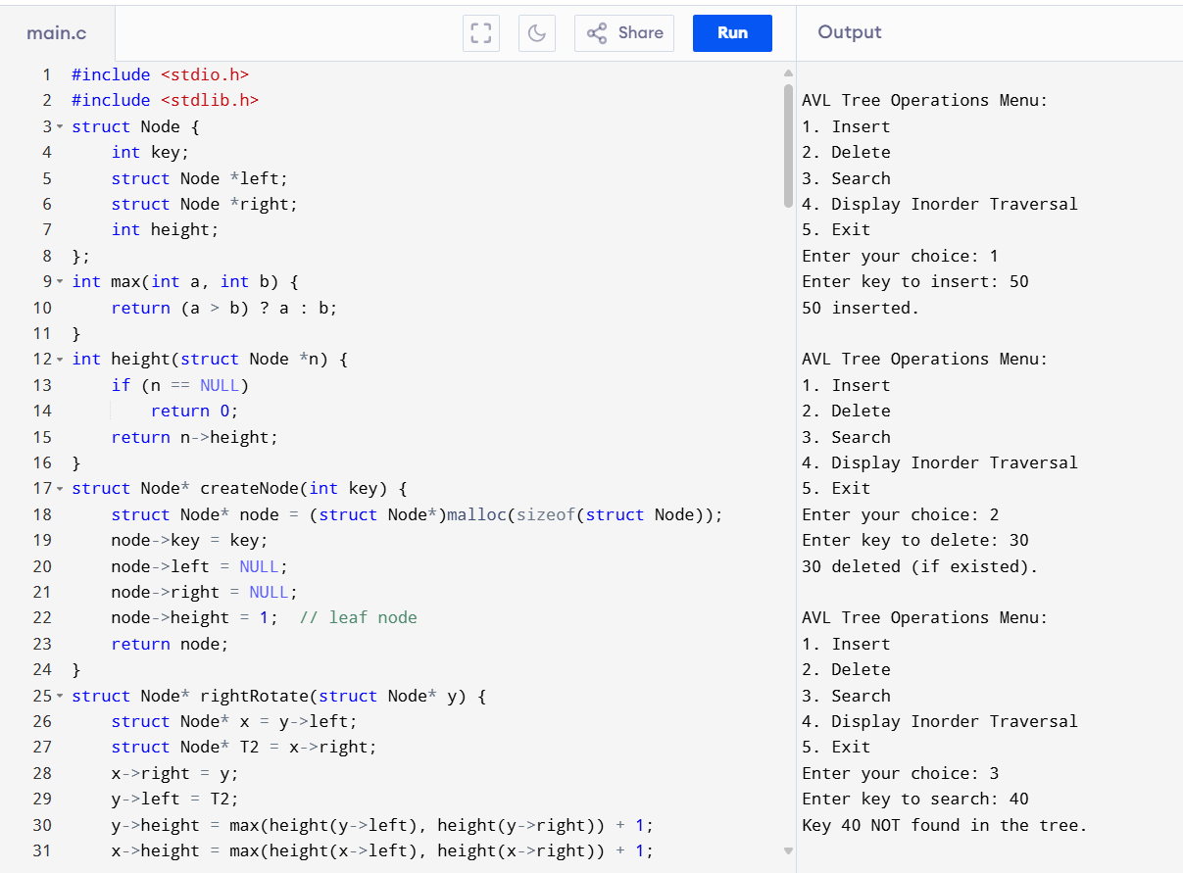

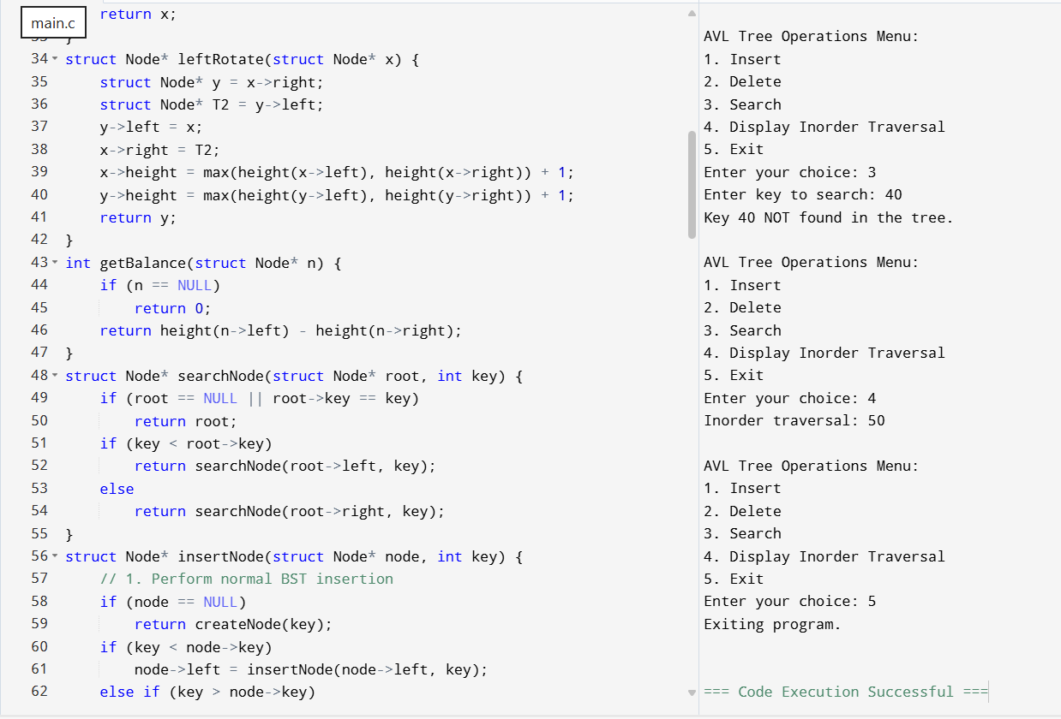

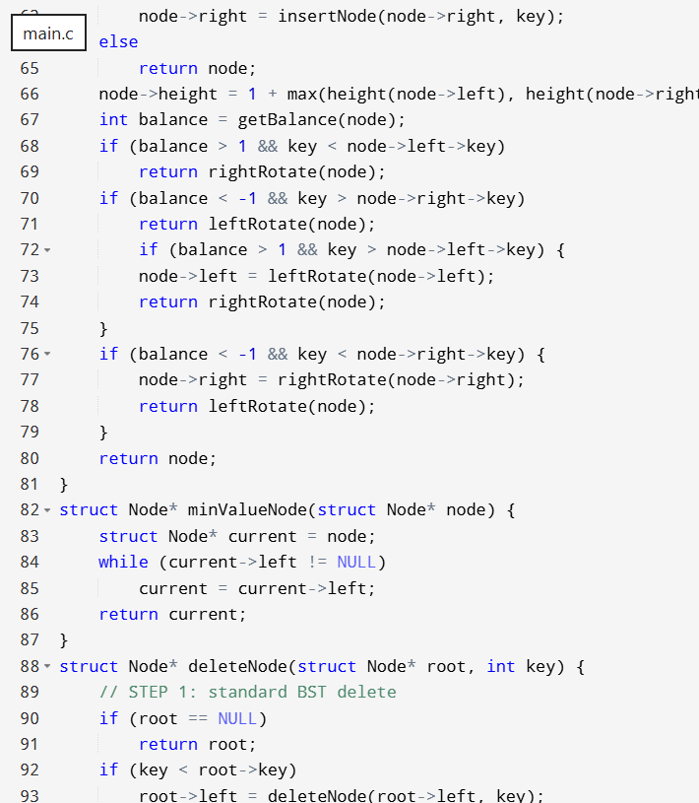

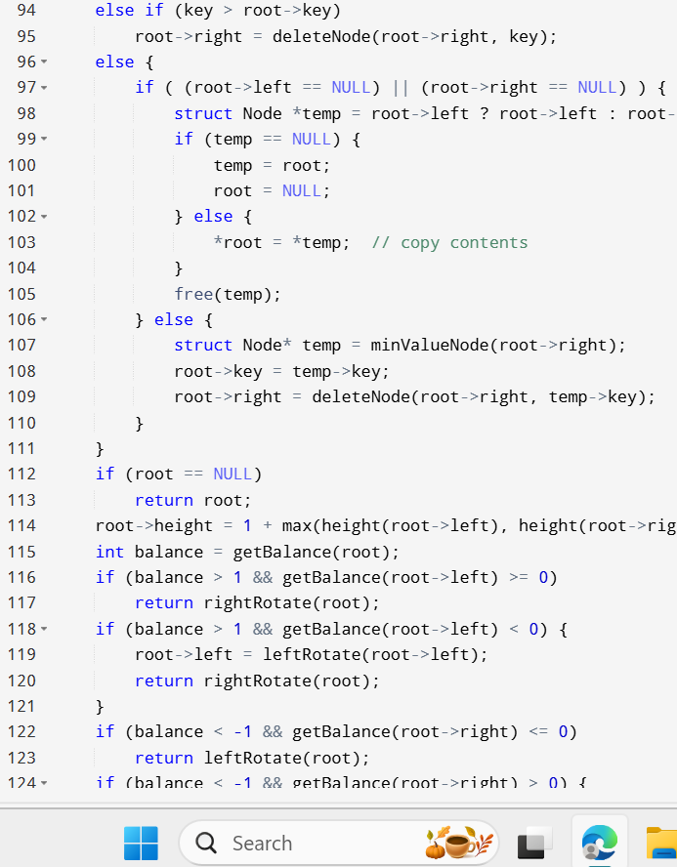

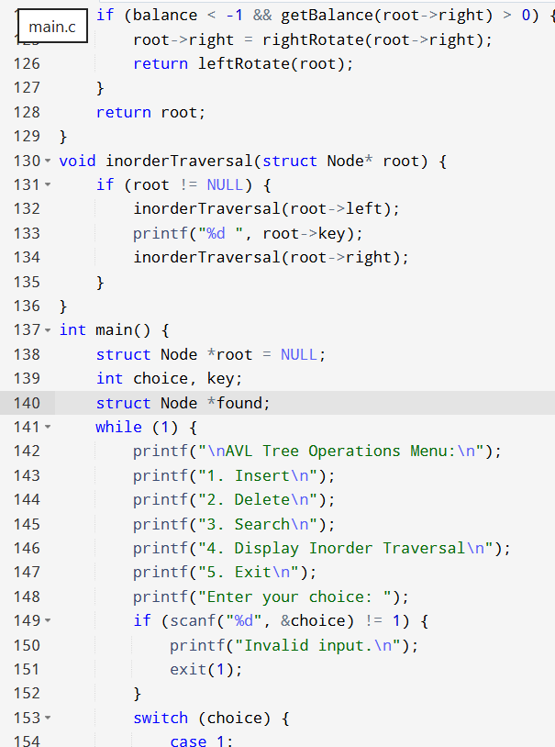

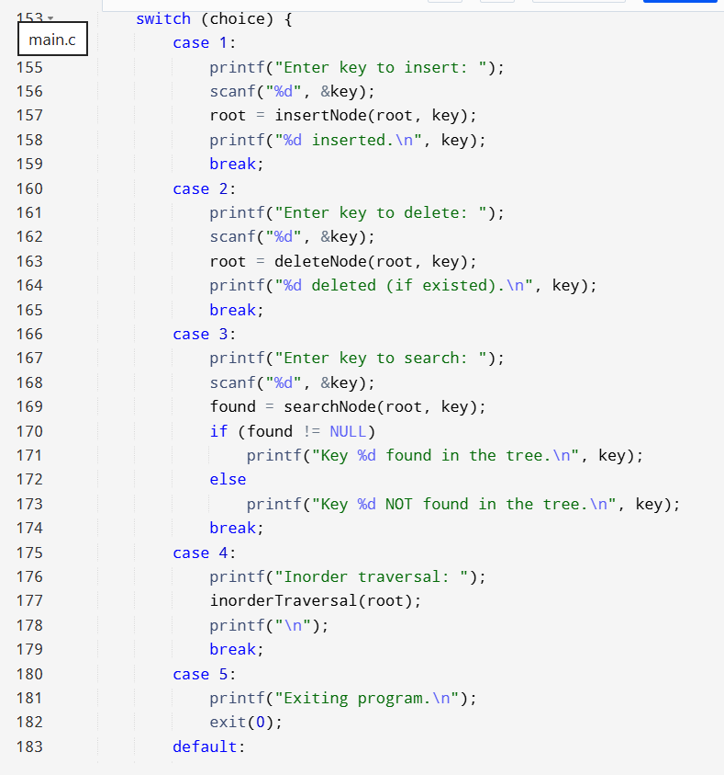

Result: The program has been executed successfully and output is verified.